SMIT R PATEL

19162121031

SEM 5

Practical 8

Big Data and Analytics

**AIM**- To understand operators in Apache Pig.

Join Operator

The **JOIN** operator is used to combine records from two or more relations. While performing a join operation, we declare one (or a group of) tuple(s) from each relation, as keys. When these keys match, the two particular tuples are matched, else the records are dropped. Joins can be of the following types −

• Self-join

• Inner-join

• Outer-join − left join, right join, and full join

This chapter explains with examples how to use the join operator in Pig Latin. Assume that we have two files namely **customers.txt** and **orders.txt** in the **/pig_data/** directory of HDFS as shown below.

**customers.txt**

1,Ramesh,32,Ahmedabad,2000.00

2,Khilan,25,Delhi,1500.00

3,kaushik,23,Kota,2000.00

4,Chaitali,25,Mumbai,6500.00

5,Hardik,27,Bhopal,8500.00

6,Komal,22,MP,4500.00

7,Muffy,24,Indore,10000.00

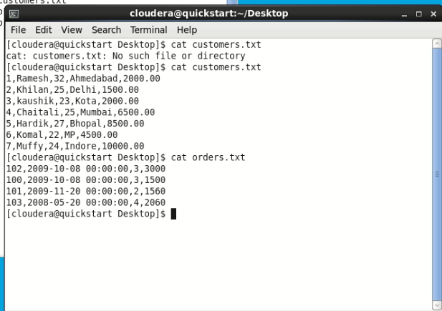

orders.txt

102,2009-10-08 00:00:00,3,3000

100,2009-10-08 00:00:00,3,1500

101,2009-11-20 00:00:00,2,1560

103,2008-05-20 00:00:00,4,2060



And we have loaded these two files into Pig with the

relations customers and orders as shown below.

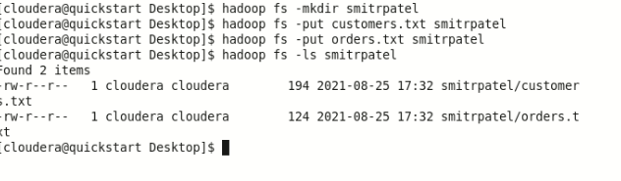

And we have loaded these two files into Pig with the relations **customers** and **orders** as shown below.

|  |
| --- |
| grunt> customers = LOAD  'hdfs://localhost:9000/pig_data/customers.txt' USING PigStorage(',')  as (id:int, name:chararray, age:int, address:chararray, salary:int);    grunt> orders = LOAD 'hdfs://localhost:9000/pig_data/orders.txt' USING PigStorage(',')  as (oid:int, date:chararray, customer_id:int, amount:int); |

Commands:

customers = load‘smitrpatel/customers.txt’ using PigStorage(',') as (id:int, name:chararray, salary:int);

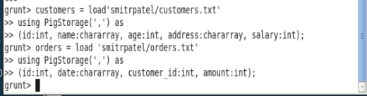

Let us now perform various Join operations on these two relations.

Self - join

**Self-join** is used to join a table with itself as if the table were two relations, temporarily renaming at least one relation.

Generally, in Apache Pig, to perform self-join, we will load the same data multiple times, under different aliases (names). Therefore let us load the contents of the file **customers.txt** as two tables as shown below.

|  |
| --- |
| grunt> customers1 = LOAD  'hdfs://localhost:9000/pig_data/customers.txt' USING PigStorage(',')  as (id:int, name:chararray, age:int, address:chararray, salary:int);    grunt> customers2 = LOAD  'hdfs://localhost:9000/pig_data/customers.txt' USING PigStorage(',')  as (id:int, name:chararray, age:int, address:chararray, salary:int); |

Command :

grunt> customers = load 'smitrpatel/customers.txt' using PigStorage(',') as (id:int, name:chararray, age:int, address:chararray, salary:int);

grunt> orders = load 'smitrpatel/orders.txt' using PigStorage(',') as (id:int, date:chararray, customer_id:int, amount:int);

grunt> customers1 = load'smitrpatel/customers.txt' using PigStorage(',') as (id:int, name:chararray, age:int, address:chararray, salary:int);

grunt> customers2 = load'smitrpatel/customers.txt' using PigStorage(',') as (id:int, name:chararray, age:int, address:chararray, salary:int);

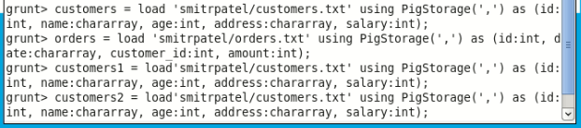

**Syntax**

Given below is the syntax of performing **self-join** operation using the **JOIN** operator.

grunt> Relation3_name = JOIN Relation1_name BY key,

Relation2_name BY key ;

**Example**

Let us perform **self-join** operation on the relation **customers**, by joining the two relations **customers1** and **customers2** as shown below.

|  |
| --- |
| grunt> customers3 = JOIN customers1 BY id, customers2 BY id; |

Command: customer3 = JOIN customers1 BY id, customers2 BY id;

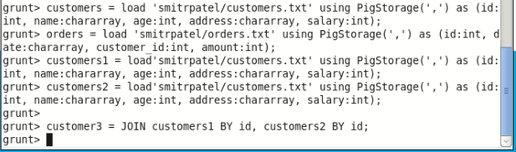

**Verification**

Verify the relation **customers3** using the **DUMP** operator as shown below.

|  |
| --- |
| grunt> Dump customers3; |

Command : dump customer3

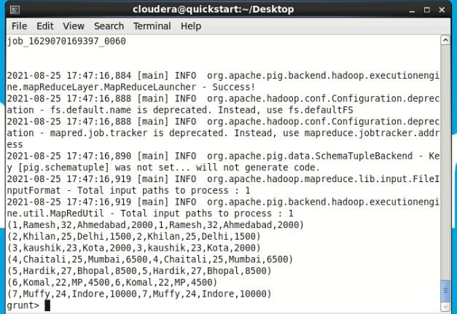

**Output**

It will produce the following output, displaying the contents of the relation **customers**.

(1,Ramesh,32,Ahmedabad,2000,1,Ramesh,32,Ahmedabad,2000) (2,Khilan,25,Delhi,1500,2,Khilan,25,Delhi,1500)

(3,kaushik,23,Kota,2000,3,kaushik,23,Kota,2000)

(4,Chaitali,25,Mumbai,6500,4,Chaitali,25,Mumbai,6500)

(5,Hardik,27,Bhopal,8500,5,Hardik,27,Bhopal,8500)

(6,Komal,22,MP,4500,6,Komal,22,MP,4500)

(7,Muffy,24,Indore,10000,7,Muffy,24,Indore,10000)

Inner Join

**Inner Join** is used quite frequently; it is also referred to as **equijoin**. An inner join returns rows when there is a match in both tables.

It creates a new relation by combining column values of two relations (say A and B) based upon the join-predicate. The query compares each row of A with each row of B to find all pairs of rows which satisfy the join-predicate. When the join-predicate is satisfied, the column values for each matched pair of rows of A and B are combined into a result row.

**Syntax**

Here is the syntax of performing **inner join** operation using the **JOIN** operator.

grunt> result = JOIN relation1 BY columnname, relation2 BY columnname;

**Example**

Let us perform **inner join** operation on the two relations **customers** and **orders** as shown below.

|  |
| --- |
| grunt> coustomer_orders = JOIN customers BY id, orders BY customer_id; |



**Verification**

Verify the relation **coustomer_orders** using the **DUMP** operator as shown below.

|  |
| --- |
| grunt> Dump coustomer_orders; |

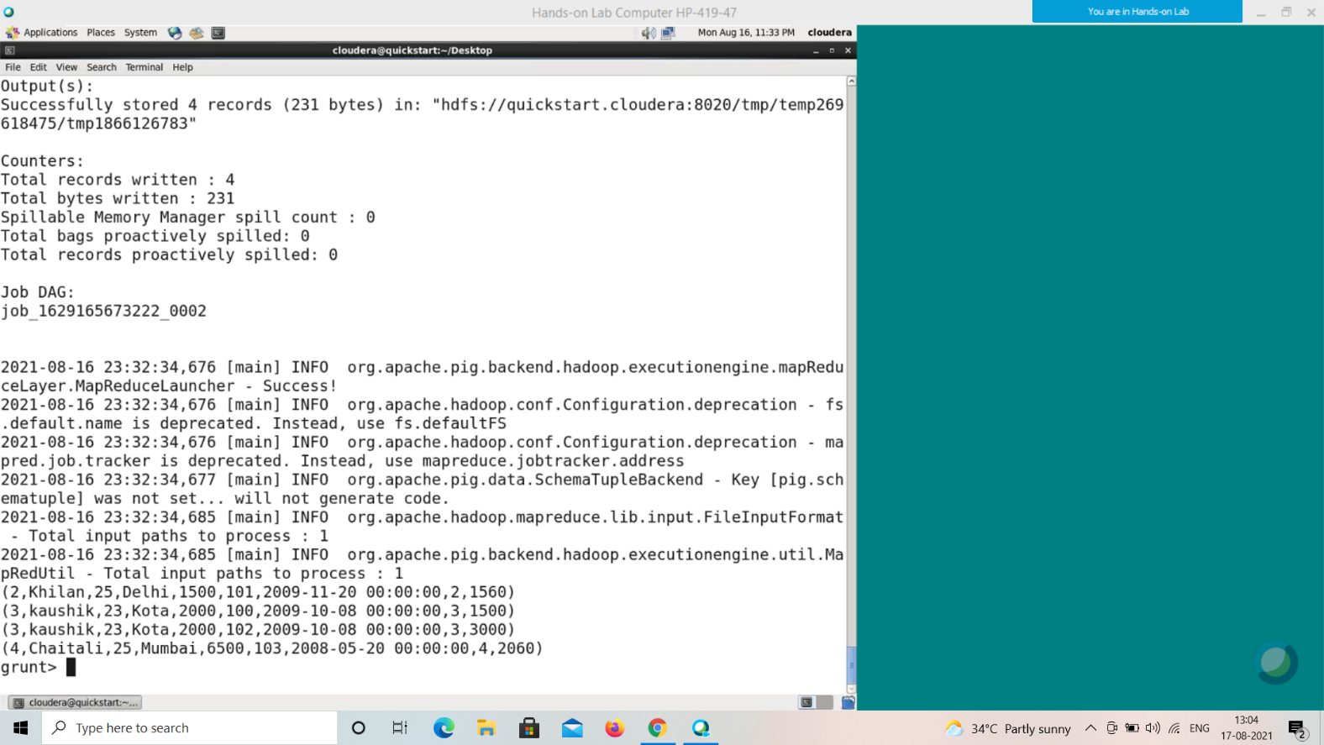

**Output**

You will get the following output that will the contents of the relation named **coustomer_orders**.

(2,Khilan,25,Delhi,1500,101,2009-11-20 00:00:00,2,1560) (3,kaushik,23,Kota,2000,100,2009-10-08 00:00:00,3,1500) (3,kaushik,23,Kota,2000,102,2009-10-08 00:00:00,3,3000) (4,Chaitali,25,Mumbai,6500,103,2008-05-20 00:00:00,4,2060)

**Note** −

*Outer Join*: Unlike inner join, **outer join** returns all the rows from at least one of the relations. An outer join operation is carried out in three ways −

• Left outer join

• Right outer join

• Full outer join

Left Outer Join

The **left outer Join** operation returns all rows from the left table, even if there are no matches in the right relation.

**Syntax**

Given below is the syntax of performing **left outer join** operation using the **JOIN** operator.

grunt> Relation3_name = JOIN Relation1_name BY id LEFT OUTER, Relation2_name BY customer_id;

**Example**

Let us perform left outer join operation on the two relations customers and orders as shown below.

|  |
| --- |
| grunt> outer_left = JOIN customers BY id LEFT OUTER, orders BY customer_id; |

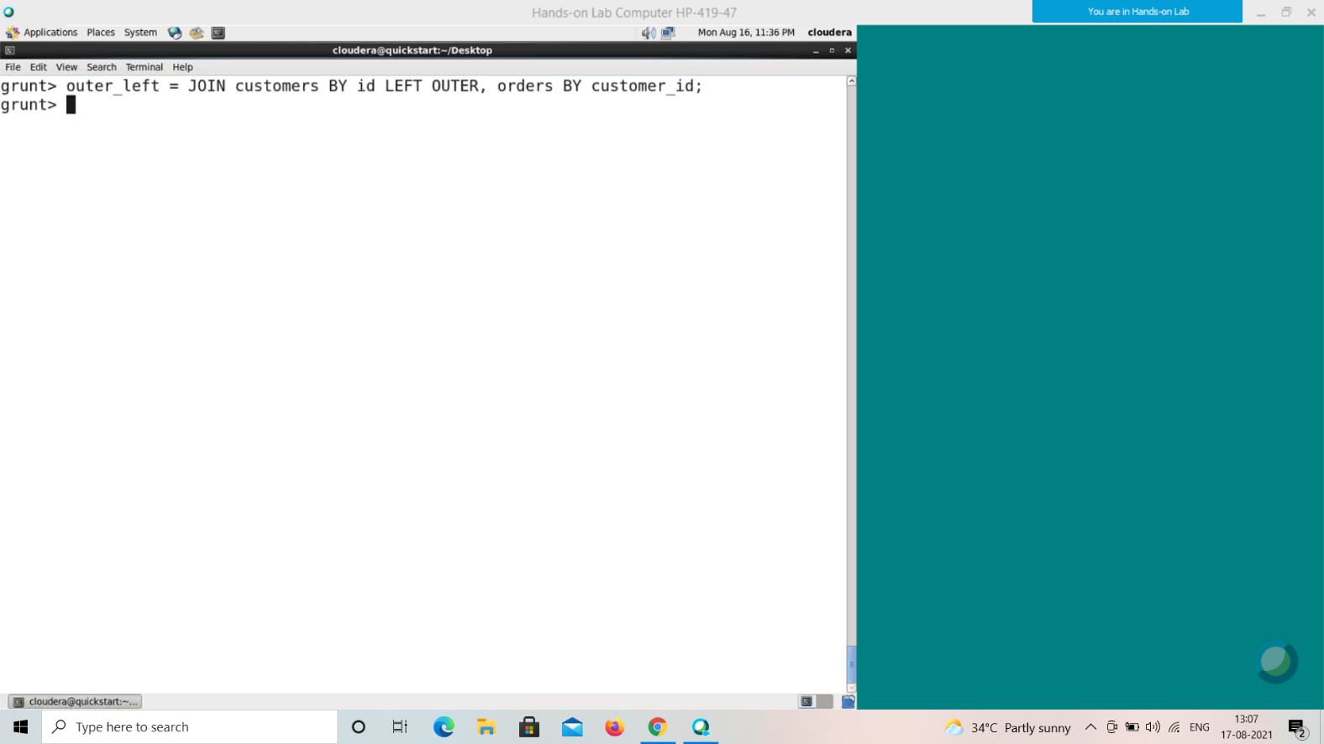

**Verification**

Verify the relation **outer_left** using the **DUMP** operator as shown below.

|  |
| --- |
| grunt> Dump outer_left; |

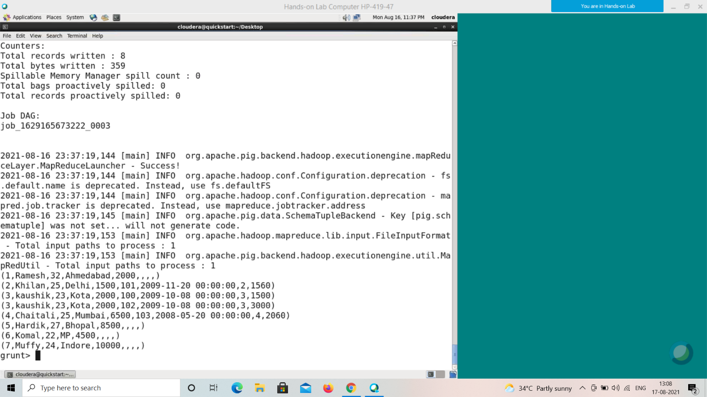

**Output**

It will produce the following output, displaying the contents of the relation **outer_left**.

(1,Ramesh,32,Ahmedabad,2000,,,,)

(2,Khilan,25,Delhi,1500,101,2009-11-20 00:00:00,2,1560) (3,kaushik,23,Kota,2000,100,2009-10-08 00:00:00,3,1500) (3,kaushik,23,Kota,2000,102,2009-10-08 00:00:00,3,3000) (4,Chaitali,25,Mumbai,6500,103,2008-05-20 00:00:00,4,2060)

(5,Hardik,27,Bhopal,8500,,,,)

(6,Komal,22,MP,4500,,,,)

(7,Muffy,24,Indore,10000,,,,)

Right Outer Join

The **right outer join** operation returns all rows from the right table, even if there are no matches in the left table.

**Syntax**

Given below is the syntax of performing **right outer join** operation using the **JOIN** operator.

grunt> outer_right = JOIN customers BY id RIGHT, orders BY customer_id;

**Example**

Let us perform **right outer join** operation on the two relations **customers** and **orders** as shown below.

|  |
| --- |
| grunt> outer_right = JOIN customers BY id RIGHT, orders BY customer_id; |

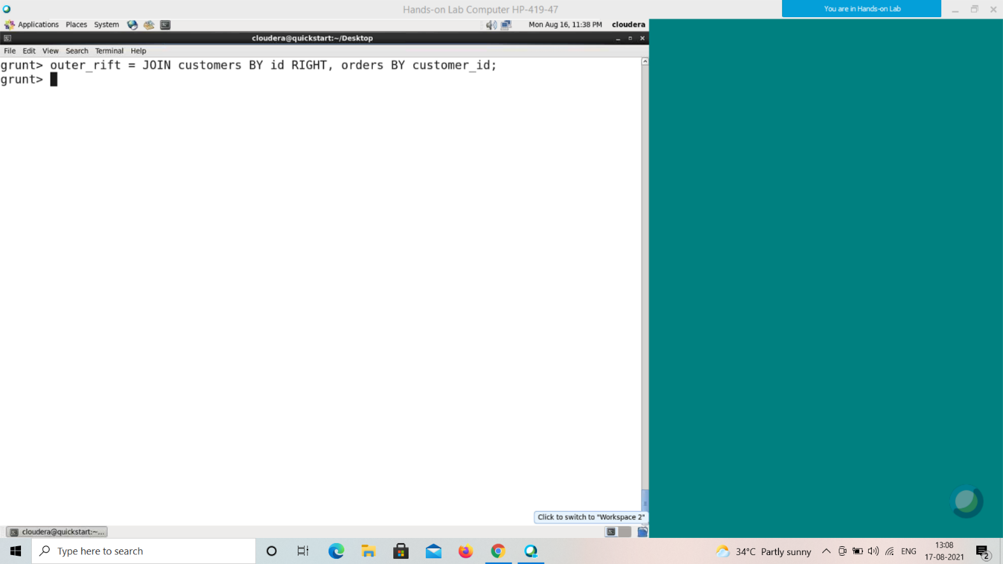

**Verification**

Verify the relation **outer_right** using the **DUMP** operator as shown below.

|  |
| --- |
| grunt> Dump outer_right |

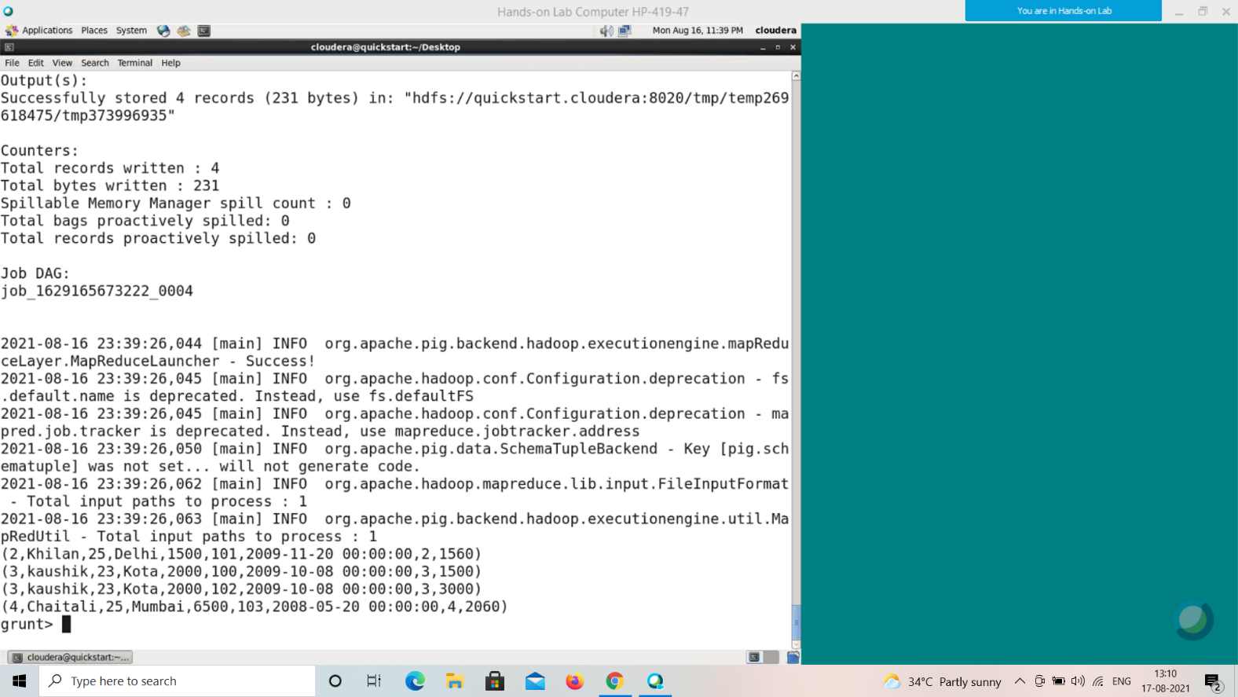

**Output**

It will produce the following output, displaying the contents of the relation **outer_right**.

(2,Khilan,25,Delhi,1500,101,2009-11-20 00:00:00,2,1560) (3,kaushik,23,Kota,2000,100,2009-10-08 00:00:00,3,1500) (3,kaushik,23,Kota,2000,102,2009-10-08 00:00:00,3,3000) (4,Chaitali,25,Mumbai,6500,103,2008-05-20 00:00:00,4,2060)

Full Outer Join

The **full outer join** operation returns rows when there is a match in one of the relations.

**Syntax**

Given below is the syntax of performing **full outer join** using the **JOIN** operator.

grunt> outer_full = JOIN customers BY id FULL OUTER, orders BY customer_id;

**Example**

Let us perform **full outer join** operation on the two relations **customers** and **orders** as shown below.

|  |
| --- |
| grunt> outer_full = JOIN customers BY id FULL OUTER, orders BY customer_id; |

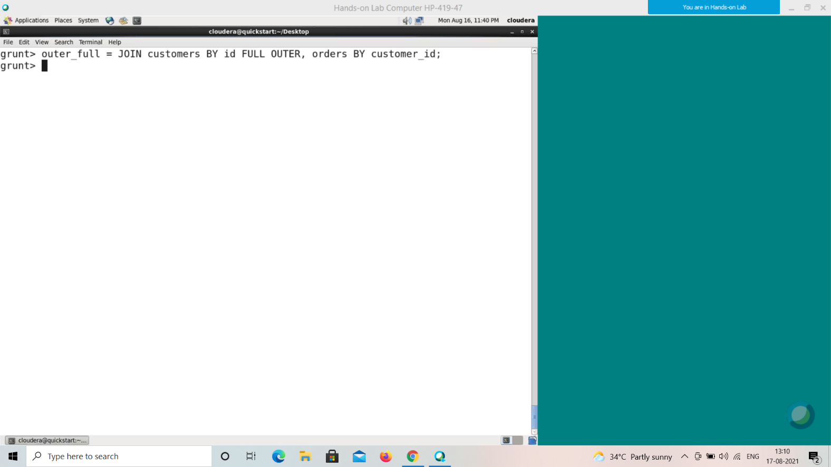

**Verification**

Verify the relation **outer_full** using the **DUMP** operator as shown below.

|  |
| --- |
| grun> Dump outer_full; |

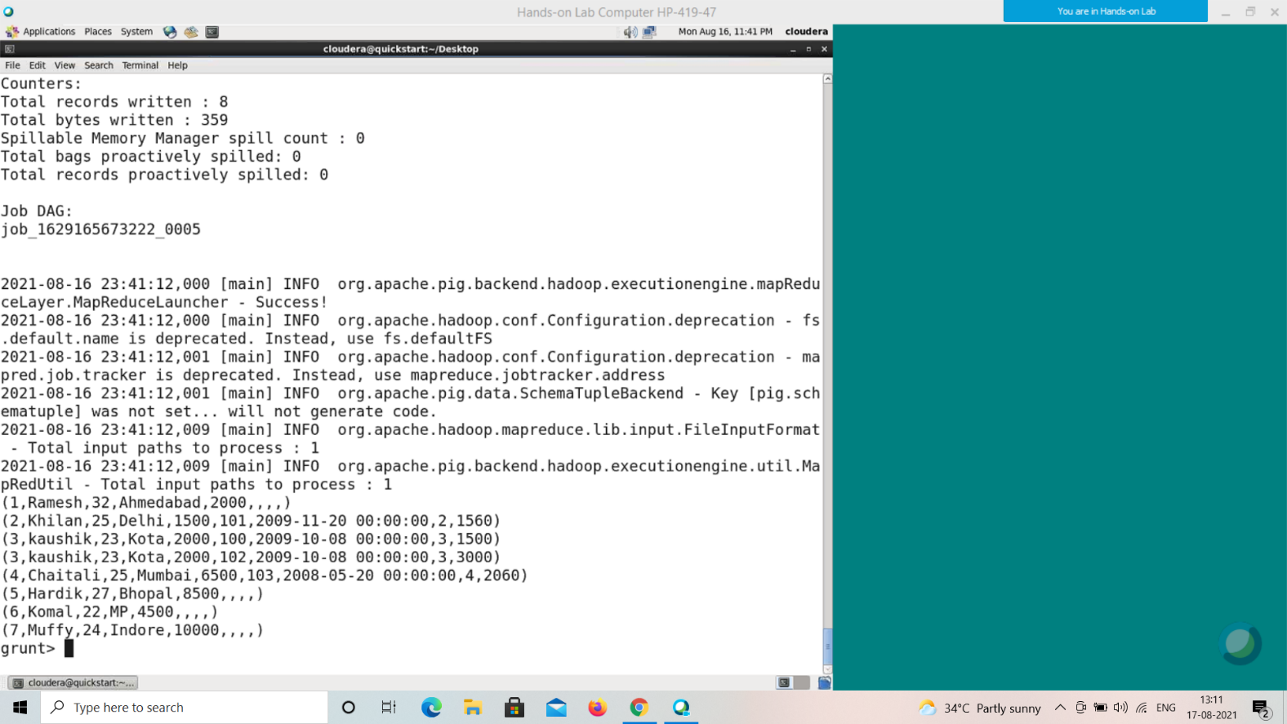

**Output**

It will produce the following output, displaying the contents of the relation **outer_full**.

(1,Ramesh,32,Ahmedabad,2000,,,,)

(2,Khilan,25,Delhi,1500,101,2009-11-20 00:00:00,2,1560) (3,kaushik,23,Kota,2000,100,2009-10-08 00:00:00,3,1500) (3,kaushik,23,Kota,2000,102,2009-10-08 00:00:00,3,3000) (4,Chaitali,25,Mumbai,6500,103,2008-05-20 00:00:00,4,2060)

(5,Hardik,27,Bhopal,8500,,,,)

(6,Komal,22,MP,4500,,,,)

(7,Muffy,24,Indore,10000,,,,)

Using Multiple Keys

We can perform JOIN operation using multiple keys.

**Syntax**

Here is how you can perform a JOIN operation on two tables using multiple keys.

grunt> Relation3_name = JOIN Relation2_name BY (key1, key2), Relation3_name BY (key1, key2);

Assume that we have two files namely **employee.txt** and **employee_contact.txt** in the **/pig_data/** directory of HDFS as shown below.

**employee.txt**

001,Rajiv,Reddy,21,programmer,003

002,siddarth,Battacharya,22,programmer,003

003,Rajesh,Khanna,22,programmer,003

004,Preethi,Agarwal,21,programmer,003

005,Trupthi,Mohanthy,23,programmer,003

006,Archana,Mishra,23,programmer,003

007,Komal,Nayak,24,teamlead,002

008,Bharathi,Nambiayar,24,manager,001

**employee_contact.txt**

001,9848022337,Rajiv@gmail.com,Hyderabad,003

002,9848022338,siddarth@gmail.com,Kolkata,003

003,9848022339,Rajesh@gmail.com,Delhi,003

004,9848022330,Preethi@gmail.com,Pune,003

005,9848022336,Trupthi@gmail.com,Bhuwaneshwar,003

006,9848022335,Archana@gmail.com,Chennai,003

007,9848022334,Komal@gmail.com,trivendram,002

008,9848022333,Bharathi@gmail.com,Chennai,001

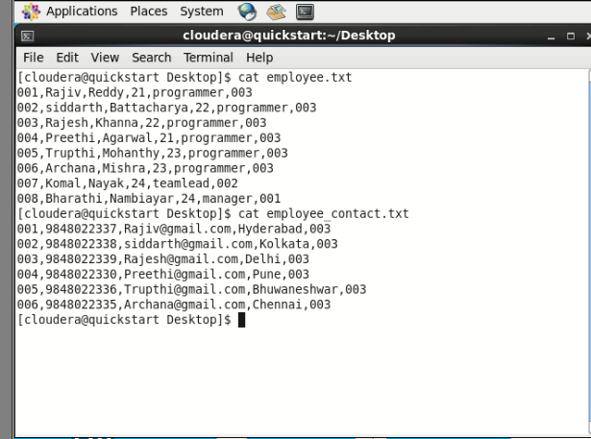

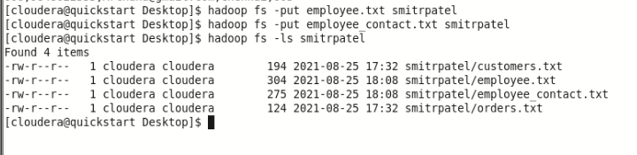

And we have loaded these two files into Pig with relations **employee** and **employee_contact** as shown below.

grunt> employee = LOAD

'hdfs://localhost:9000/pig_data/employee.txt' USING

PigStorage(',')

as (id:int, firstname:chararray, lastname:chararray, age:int, designation:chararray, jobid:int);

grunt> employee_contact = LOAD

'hdfs://localhost:9000/pig_data/employee_contact.txt' USING PigStorage(',')

as (id:int, phone:chararray, email:chararray, city:chararray, jobid:int);

command :

employee = LOAD ‘smitrpatel/employee.txt’ USING PigStorage(',') as (id:int, firstname:chararray, lastname:chararray, age:int, designation:chararray, jobid:int);

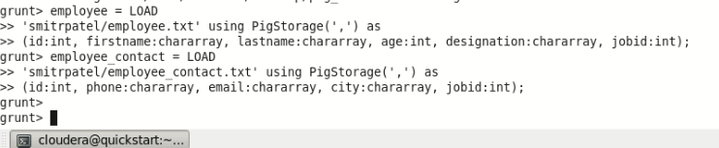

Now, let us join the contents of these two relations using the **JOIN** operator as shown below.

|  |
| --- |
| grunt> emp = JOIN employee BY (id,jobid), employee_contact BY (id,jobid); |

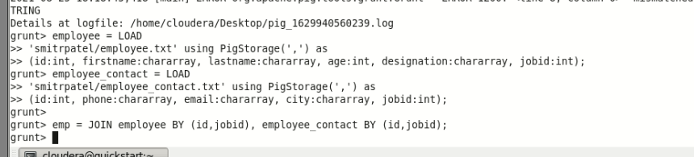

**Verification**

Verify the relation **emp** using the **DUMP** operator as shown below.

|  |
| --- |
| grunt> Dump emp; |

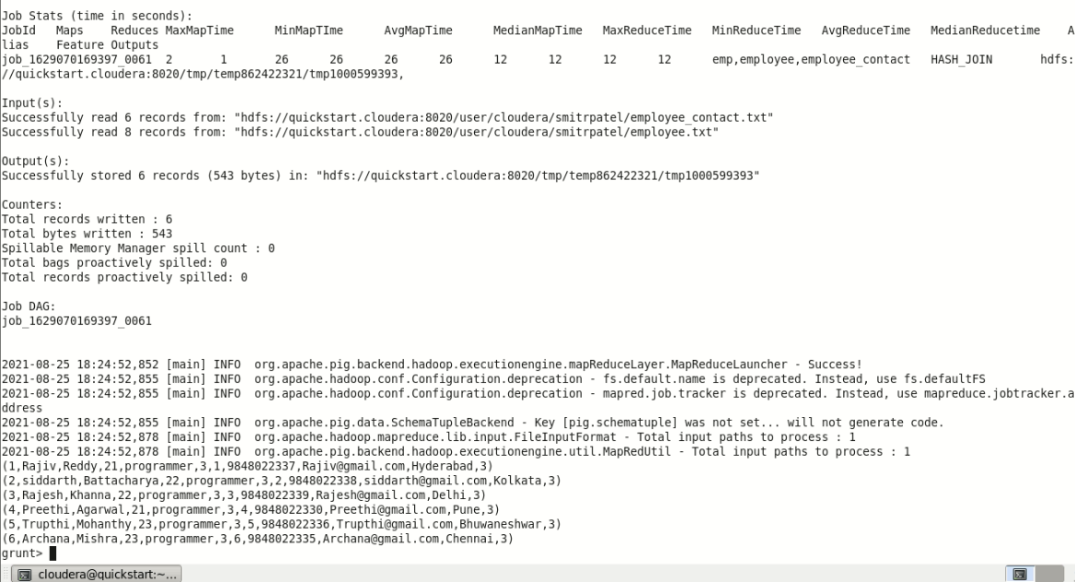

**Output**

It will produce the following output, displaying the contents of the relation named **emp** as shown below.

2021-08-25 18:24:52,852 [main] INFO org.apache.pig.backend.hadoop.executionengine.mapReduceLayer.MapReduceLauncher - Success!

2021-08-25 18:24:52,855 [main] INFO org.apache.hadoop.conf.Configuration.deprecation - fs.default.name is deprecated. Instead, use fs.defaultFS

2021-08-25 18:24:52,855 [main] INFO org.apache.hadoop.conf.Configuration.deprecation - mapred.job.tracker is deprecated. Instead, use mapreduce.jobtracker.address

2021-08-25 18:24:52,855 [main] INFO org.apache.pig.data.SchemaTupleBackend - Key [pig.schematuple] was not set... will not generate code.

2021-08-25 18:24:52,878 [main] INFO org.apache.hadoop.mapreduce.lib.input.FileInputFormat - Total input paths to process : 1

2021-08-25 18:24:52,878 [main] INFO org.apache.pig.backend.hadoop.executionengine.util.MapRedUtil - Total input paths to process : 1

(1,Rajiv,Reddy,21,programmer,3,1,9848022337,Rajiv@gmail.com,Hyderabad,3)

(2,siddarth,Battacharya,22,programmer,3,2,9848022338,siddarth@gmail.com,Kolkata,3)

(3,Rajesh,Khanna,22,programmer,3,3,9848022339,Rajesh@gmail.com,Delhi,3)

(4,Preethi,Agarwal,21,programmer,3,4,9848022330,Preethi@gmail.com,Pune,3)

(5,Trupthi,Mohanthy,23,programmer,3,5,9848022336,Trupthi@gmail.com,Bhuwaneshwar,3)

(6,Archana,Mishra,23,programmer,3,6,9848022335,Archana@gmail.com,Chennai,3)

CROSS OPERATOR

The CROSS operator computes the cross-product of two or more relations. This chapter explains with example how to use the cross operator in Pig Latin.

Syntax

Given below is the syntax of the CROSS operator.

grunt> Relation3_name = CROSS Relation1_name, Relation2_name;

And we have loaded these two files into Pig with the relations customers and orders.

Let us now get the cross-product of these two relations using the cross operator on these two relations as shown below.

grunt> cross_data = CROSS customers, orders;

|  |
| --- |
| grunt> cross_data = CROSS customers, orders; |

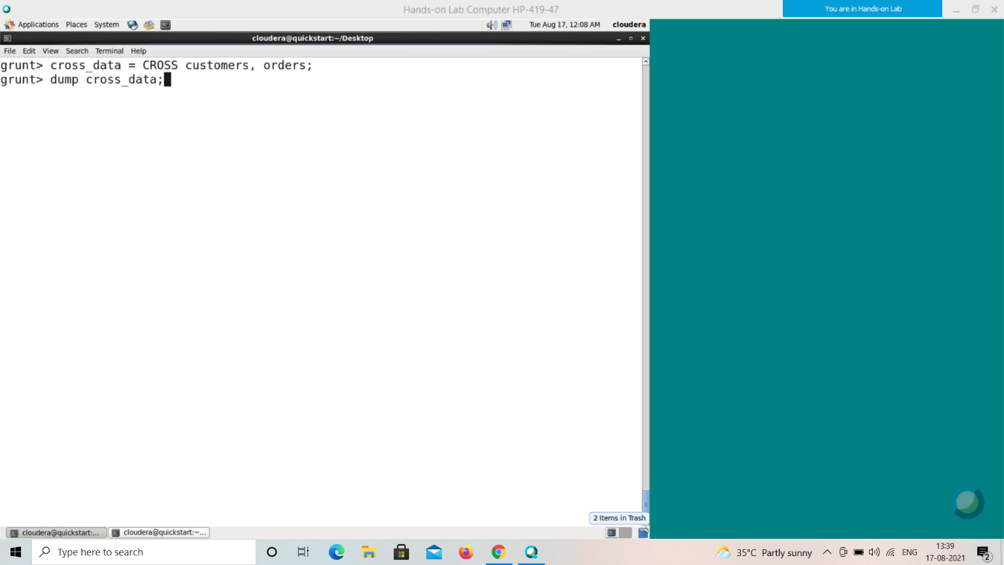

**Verification**

Verify the relation **cross_data** using the **DUMP** operator as shown below.

|  |
| --- |
| grunt> Dump cross_data; |

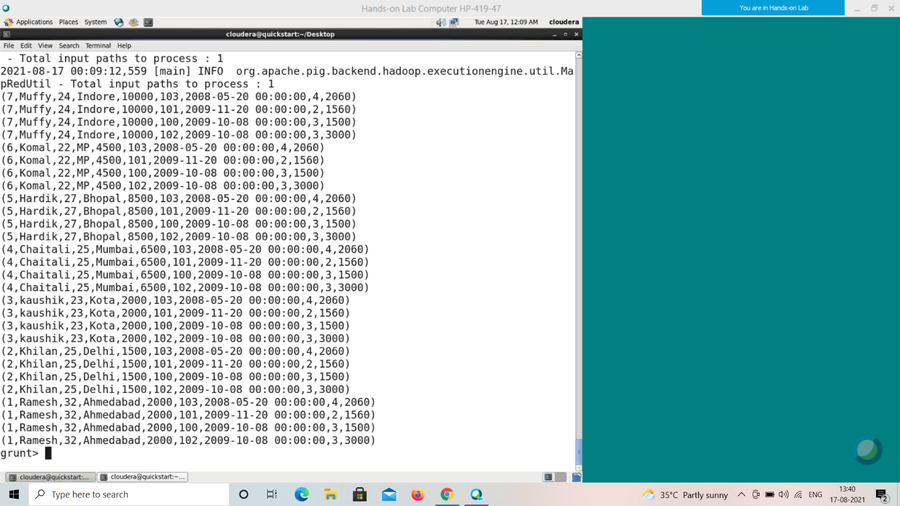

**Output**

It will produce the following output, displaying the contents of the relation **cross_data**.

(7,Muffy,24,Indore,10000,103,2008-05-20 00:00:00,4,2060) (7,Muffy,24,Indore,10000,101,2009-11-20 00:00:00,2,1560) (7,Muffy,24,Indore,10000,100,2009-10-08 00:00:00,3,1500) (7,Muffy,24,Indore,10000,102,2009-10-08 00:00:00,3,3000) (6,Komal,22,MP,4500,103,2008-05-20 00:00:00,4,2060)

(6,Komal,22,MP,4500,101,2009-11-20 00:00:00,2,1560)

(6,Komal,22,MP,4500,100,2009-10-08 00:00:00,3,1500)

(6,Komal,22,MP,4500,102,2009-10-08 00:00:00,3,3000)

(5,Hardik,27,Bhopal,8500,103,2008-05-20 00:00:00,4,2060) (5,Hardik,27,Bhopal,8500,101,2009-11-20 00:00:00,2,1560) (5,Hardik,27,Bhopal,8500,100,2009-10-08 00:00:00,3,1500) (5,Hardik,27,Bhopal,8500,102,2009-10-08 00:00:00,3,3000) (4,Chaitali,25,Mumbai,6500,103,2008-05-20 00:00:00,4,2060)

(4,Chaitali,25,Mumbai,6500,101,2009-20 00:00:00,4,2060) (2,Khilan,25,Delhi,1500,101,2009-11-20 00:00:00,2,1560) (2,Khilan,25,Delhi,1500,100,2009-10-08 00:00:00,3,1500) (2,Khilan,25,Delhi,1500,102,2009-10-08 00:00:00,3,3000) (1,Ramesh,32,Ahmedabad,2000,103,2008-05-20 00:00:00,4,2060)

(1,Ramesh,32,Ahmedabad,2000,101,2009-11-20 00:00:00,2,1560) (1,Ramesh,32,Ahmedabad,2000,100,2009-10-08 00:00:00,3,1500) (1,Ramesh,32,Ahmedabad,2000,102,2009-10-08 00:00:00,3,3000)-11-20 00:00:00,2,1560)

(4,Chaitali,25,Mumbai,6500,100,2009-10-08 00:00:00,3,1500) (4,Chaitali,25,Mumbai,6500,102,2009-10-08 00:00:00,3,3000) (3,kaushik,23,Kota,2000,103,2008-05-20 00:00:00,4,2060) (3,kaushik,23,Kota,2000,101,2009-11-20 00:00:00,2,1560) (3,kaushik,23,Kota,2000,100,2009-10-08 00:00:00,3,1500) (3,kaushik,23,Kota,2000,102,2009-10-08 00:00:00,3,3000) (2,Khilan,25,Delhi,1500,103,2008-05-20 00:00:00,4,2060) (2,Khilan,25,Delhi,1500,101,2009-11-20 00:00:00,2,1560) (2,Khilan,25,Delhi,1500,100,2009-10-08 00:00:00,3,1500) (2,Khilan,25,Delhi,1500,102,2009-10-08 00:00:00,3,3000) (1,Ramesh,32,Ahmedabad,2000,103,2008-05-20 00:00:00,4,2060) (1,Ramesh,32,Ahmedabad,2000,101,2009-11-20 00:00:00,2,1560) (1,Ramesh,32,Ahmedabad,2000,100,2009-10-08 00:00:00,3,1500) (1,Ramesh,32,Ahmedabad,2000,102,2009-10-08 00:00:00,3,3000)

Union Operator

The **UNION** operator of Pig Latin is used to merge the content of two relations. To perform UNION operation on two relations, their columns and domains must be identical.

Syntax

Given below is the syntax of the **UNION** operator.

grunt> Relation_name3 = UNION Relation_name1, Relation_name2; Example

Assume that we have two files namely **student_data1.txt** and **student_data2.txt** in the **/pig_data/** directory of HDFS as shown below.

**Student_data1.txt**

001,Rajiv,Reddy,9848022337,Hyderabad

002,siddarth,Battacharya,9848022338,Kolkata

003,Rajesh,Khanna,9848022339,Delhi

004,Preethi,Agarwal,9848022330,Pune

005,Trupthi,Mohanthy,9848022336,Bhuwaneshwar

006,Archana,Mishra,9848022335,Chennai.

**Student_data2.txt**

7,Komal,Nayak,9848022334,trivendram.

8,Bharathi,Nambiayar,9848022333,Chennai.

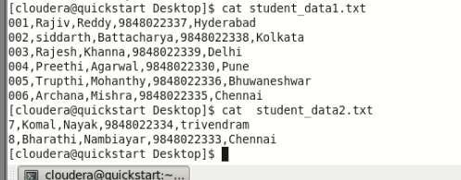

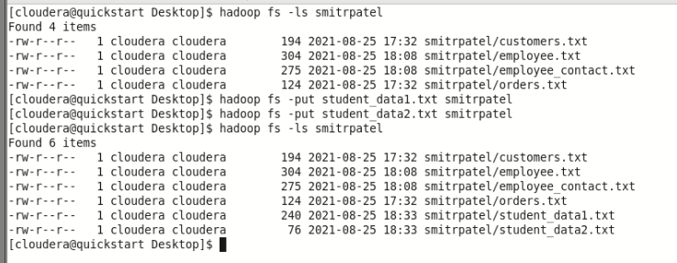

And we have loaded these two files into Pig with the relations **student1** and **student2** as shown below.

|  |
| --- |
| grunt> student1 = LOAD  'hdfs://localhost:9000/pig_data/student_data1.txt' USING PigStorage(',')  as (id:int, firstname:chararray, lastname:chararray, phone:chararray, city:chararray);  grunt> student2 = LOAD  'hdfs://localhost:9000/pig_data/student_data2.txt' USING PigStorage(',')  as (id:int, firstname:chararray, lastname:chararray, phone:chararray, city:chararray); |

grunt> student1 = load 'smitrpatel/student_data1.txt' using

>> PigStorage(',') as

>> (id:int, firstname:chararray, lastname:chararray, phone:chararray, city:chararray);

grunt> student2 = load 'smitrpatel/student_data2.txt' using

>> PigStorage(',') as

>> (id:int, firstname:chararray, lastname:chararray, phone:chararray, city:chararray);

grunt>

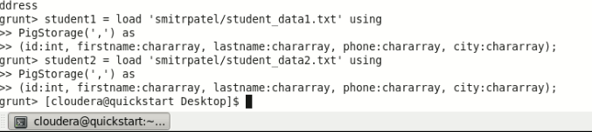

Let us now merge the contents of these two relations using the **UNION** operator as shown below.

|  |
| --- |
| grunt> student = UNION student1, student2; |

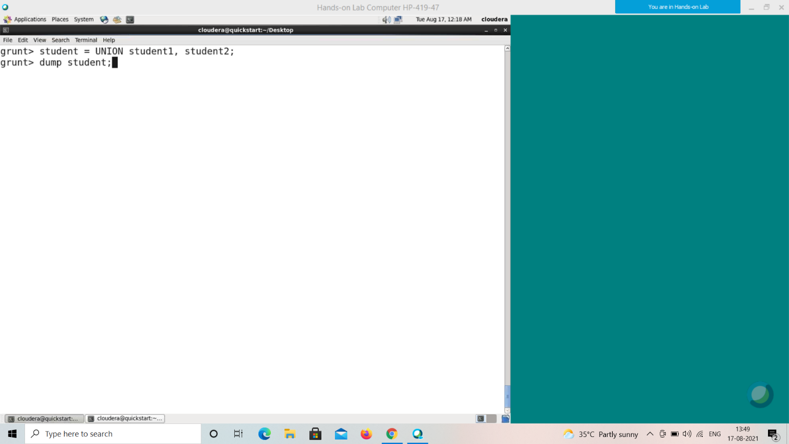

**Verification**

Verify the relation **student** using the **DUMP** operator as shown below.

|  |
| --- |
| grunt> Dump student; |

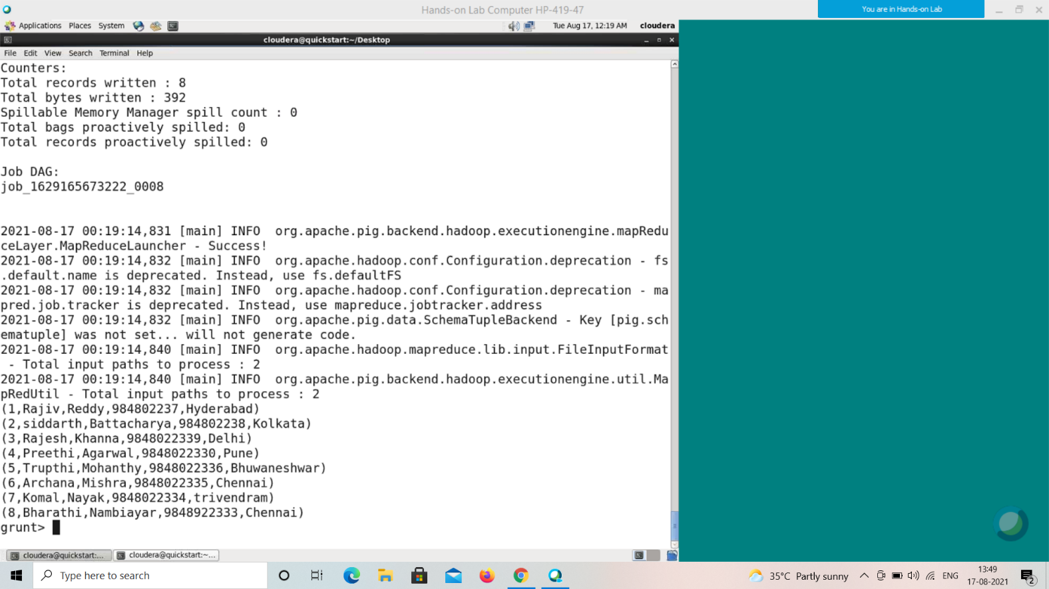

**Output**

It will display the following output, displaying the contents of the relation **student**.

(1,Rajiv,Reddy,9848022337,Hyderabad)

(2,siddarth,Battacharya,9848022338,Kolkata)

(3,Rajesh,Khanna,9848022339,Delhi)

(4,Preethi,Agarwal,9848022330,Pune)

(5,Trupthi,Mohanthy,9848022336,Bhuwaneshwar)

(6,Archana,Mishra,9848022335,Chennai)

(7,Komal,Nayak,9848022334,trivendram)

(8,Bharathi,Nambiayar,9848022333,Chennai)

Split Operator

The **SPLIT** operator is used to split a relation into two or more relations. Syntax

Given below is the syntax of the **SPLIT** operator.

grunt> SPLIT Relation1_name INTO Relation2_name IF (condition1), Relation2_name (condition2),

Example

Assume that we have a file named **student_details.txt** in the HDFS directory **/pig_data/** as shown below.

**student_details.txt**

001,Rajiv,Reddy,21,9848022337,Hyderabad

002,siddarth,Battacharya,22,9848022338,Kolkata

003,Rajesh,Khanna,22,9848022339,Delhi

004,Preethi,Agarwal,21,9848022330,Pune

005,Trupthi,Mohanthy,23,9848022336,Bhuwaneshwar

006,Archana,Mishra,23,9848022335,Chennai

007,Komal,Nayak,24,9848022334,trivendram

008,Bharathi,Nambiayar,24,9848022333,Chennai

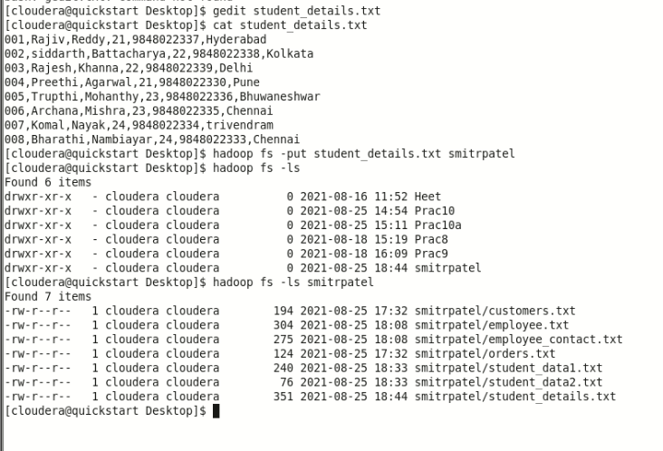

And we have loaded this file into Pig with the relation name **student_details** as shown below.

|  |
| --- |
| student_details = LOAD  'hdfs://localhost:9000/pig_data/student_details.txt' USING PigStorage(',')  as (id:int, firstname:chararray, lastname:chararray, age:int, phone:chararray, city:chararray); |

grunt> student_details = load'smitrpatel/student_details.txt'

> using PigStorage(',') as

>> (id:int, firstname:chararray, lastname:chararray, age:int, phone:chararray, city:chararray);

grunt> student_details1 = load'smitrpatel/student_details1.txt'

>> using PigStorage(',') as

>> (id:int, firstname:chararray, lastname:chararray, age:int, phone:chararray, city:chararray);

grunt> student_details2 = load'smitrpatel/student_details2.txt'

>> using PigStorage(',') as

>> (id:int, firstname:chararray, lastname:chararray, age:int, phone:chararray, city:chararray);

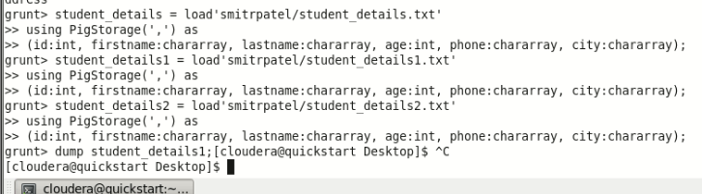

Let us now split the relation into two, one listing the employees of age less than 23, and the other listing the employees having the age between 22 and 25.

|  |
| --- |
| SPLIT student_details into student_details1 if age<23, student_details2 if (22<age and age>25); |

Command : grunt>SPLIT student_details into student_details1 if age<23, student_details2 if (age>22 and age<25);

**Verification**

Verify the relations **student_details1** and **student_details2** using the **DUMP** operator as shown below.

|  |
| --- |
| grunt> Dump student_details1;  grunt> Dump student_details2; |

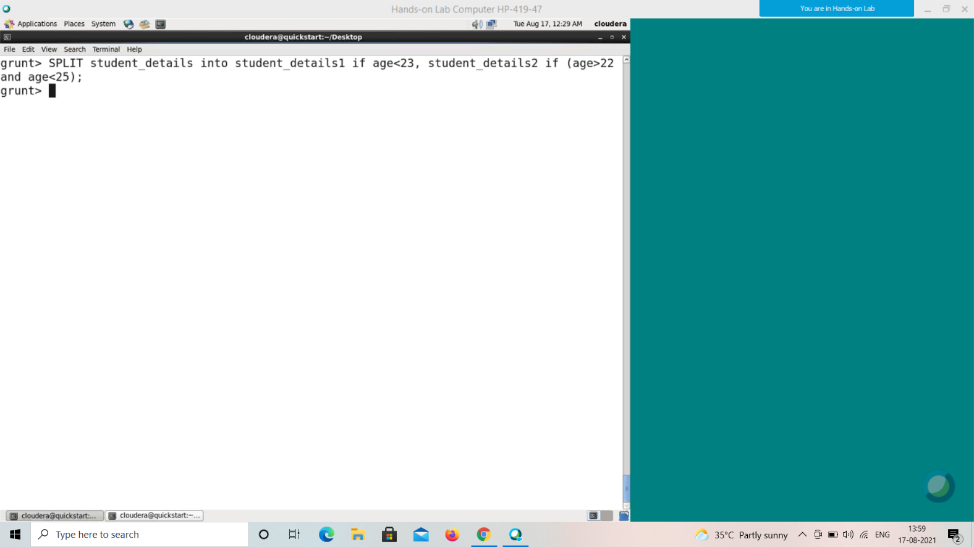

**Output**

It will produce the following output, displaying the contents of the relations **student_details1** and **student_details2** respectively.

**grunt> Dump student_details1;**

(1,Rajiv,Reddy,21,9848022337,Hyderabad)

(2,siddarth,Battacharya,22,9848022338,Kolkata)

(3,Rajesh,Khanna,22,9848022339,Delhi)

(4,Preethi,Agarwal,21,9848022330,Pune)

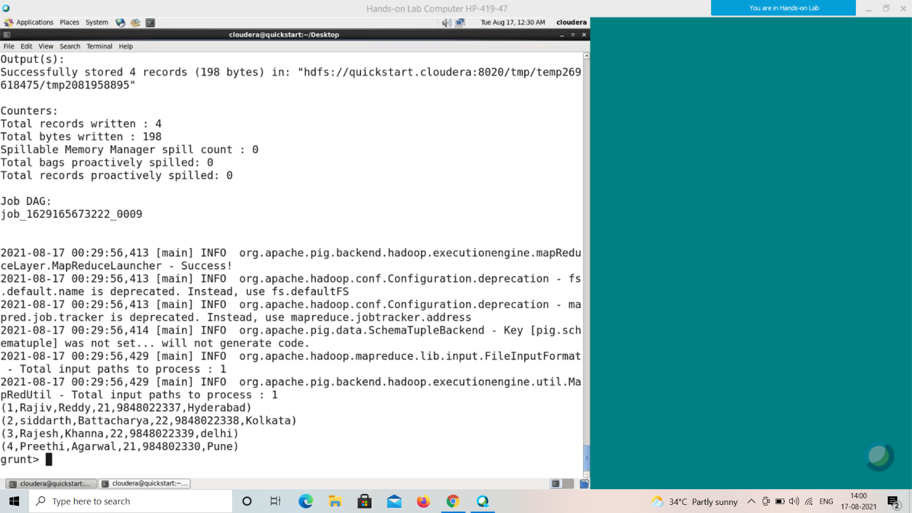

**grunt> Dump student_details2;**

(5,Trupthi,Mohanthy,23,9848022336,Bhuwaneshwar)

(6,Archana,Mishra,23,9848022335,Chennai)

(7,Komal,Nayak,24,9848022334,trivendram)

(8,Bharathi,Nambiayar,24,9848022333,Chennai)

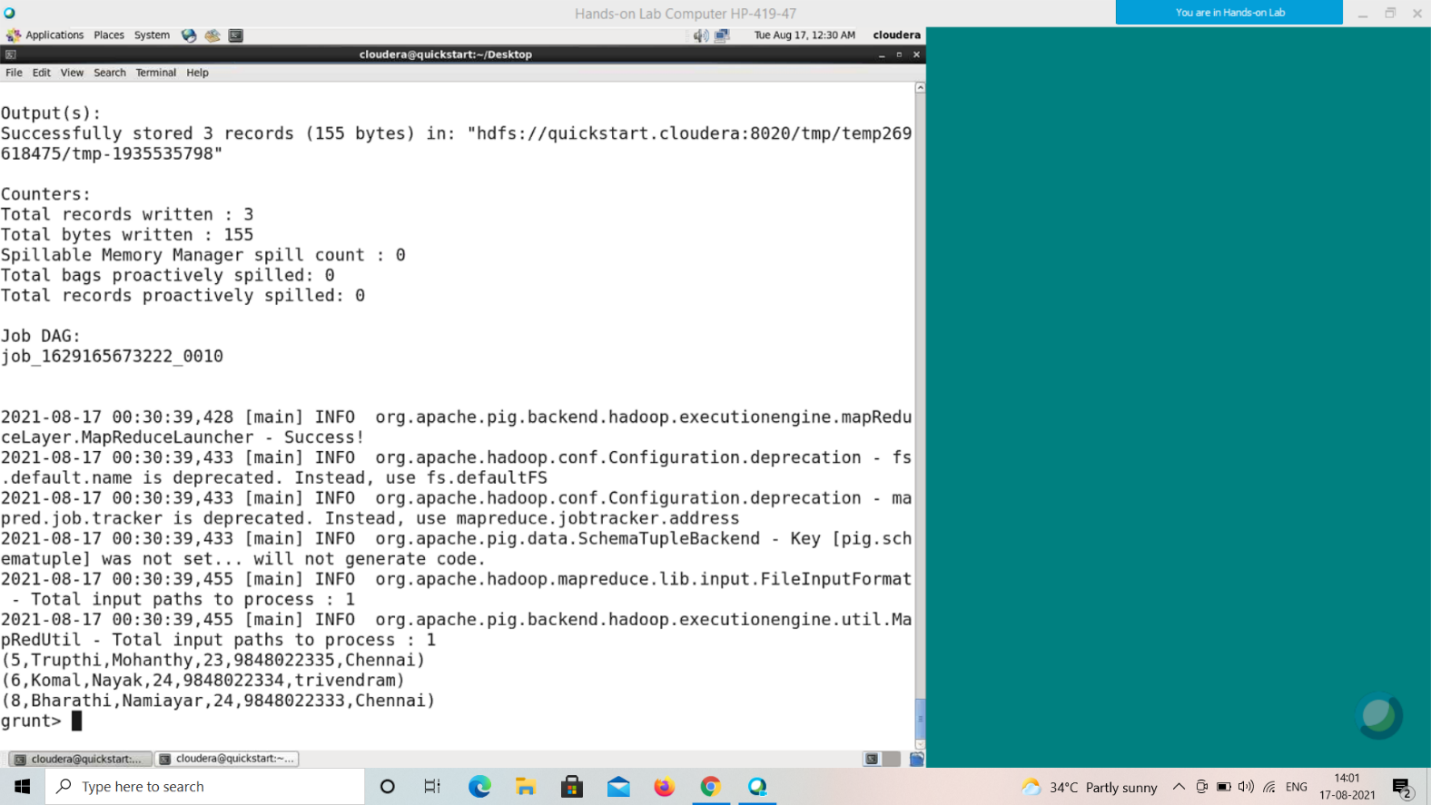

Filter Operator

The **FILTER** operator is used to select the required tuples from a relation based on a condition.

Syntax

Given below is the syntax of the **FILTER** operator.

grunt> Relation2_name = FILTER Relation1_name BY (condition); Example

Assume that we have a file named **student_details.txt** in the HDFS directory **/pig_data/** as shown below.

**student_details.txt**

001,Rajiv,Reddy,21,9848022337,Hyderabad

002,siddarth,Battacharya,22,9848022338,Kolkata

003,Rajesh,Khanna,22,9848022339,Delhi

004,Preethi,Agarwal,21,9848022330,Pune

005,Trupthi,Mohanthy,23,9848022336,Bhuwaneshwar

006,Archana,Mishra,23,9848022335,Chennai

007,Komal,Nayak,24,9848022334,trivendram

008,Bharathi,Nambiayar,24,9848022333,Chennai

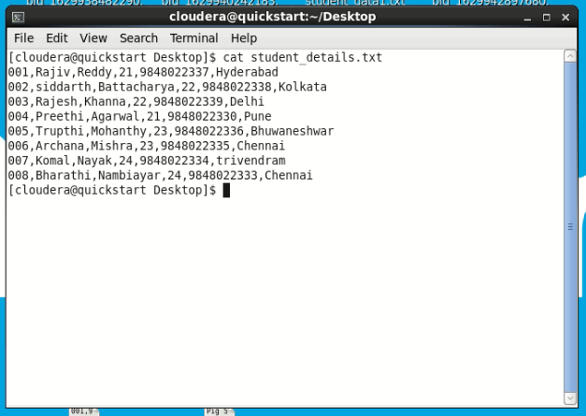

And we have loaded this file into Pig with the relation name **student_details** as shown below.

|  |
| --- |
| grunt> student_details = LOAD  'hdfs://localhost:9000/pig_data/student_details.txt' USING PigStorage(',')  as (id:int, firstname:chararray, lastname:chararray, age:int, phone:chararray, city:chararray); |

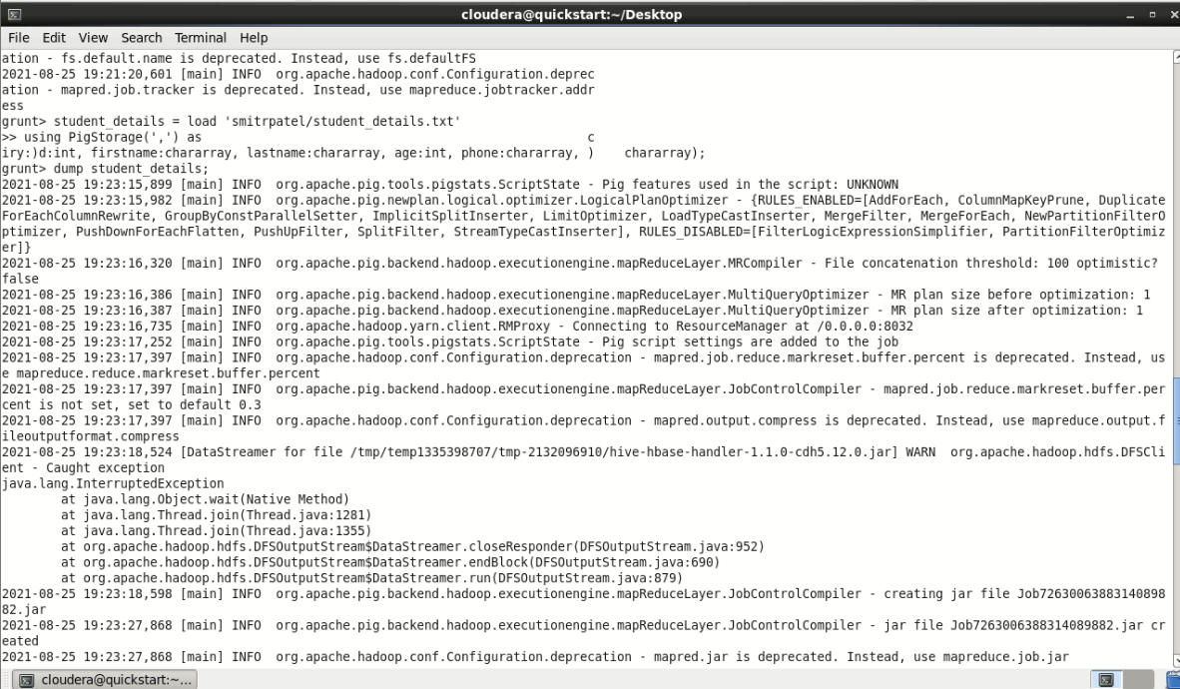

Let us now use the Filter operator to get the details of the students who belong to the city Chennai.

|  |
| --- |
| filter_data = FILTER student_details BY city == 'Chennai'; |

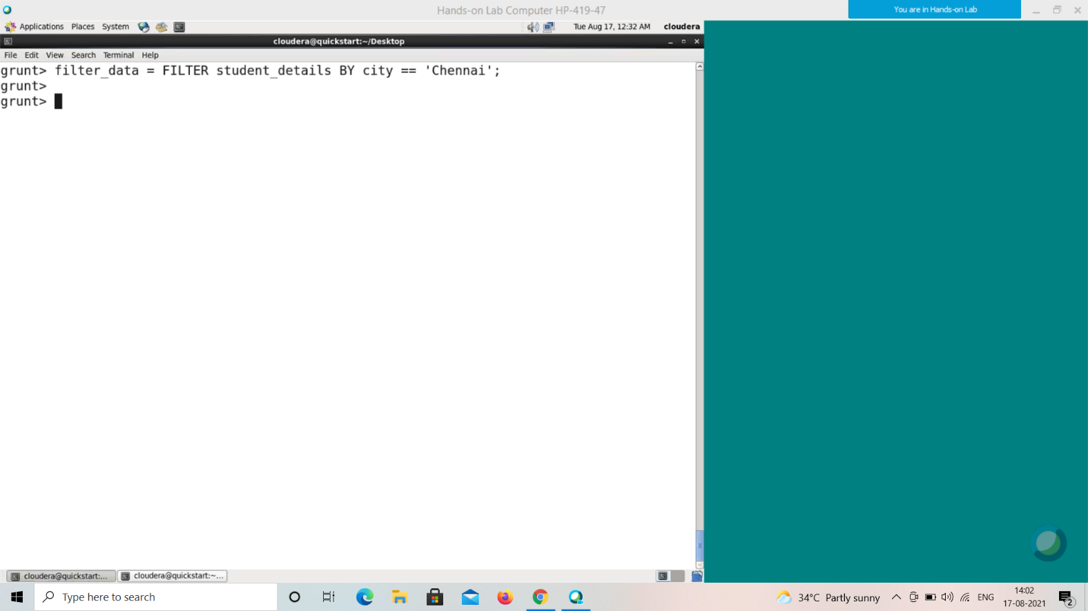

**Verification**

Verify the relation **filter_data** using the **DUMP** operator as shown below.

|  |
| --- |
| grunt> Dump filter_data; |

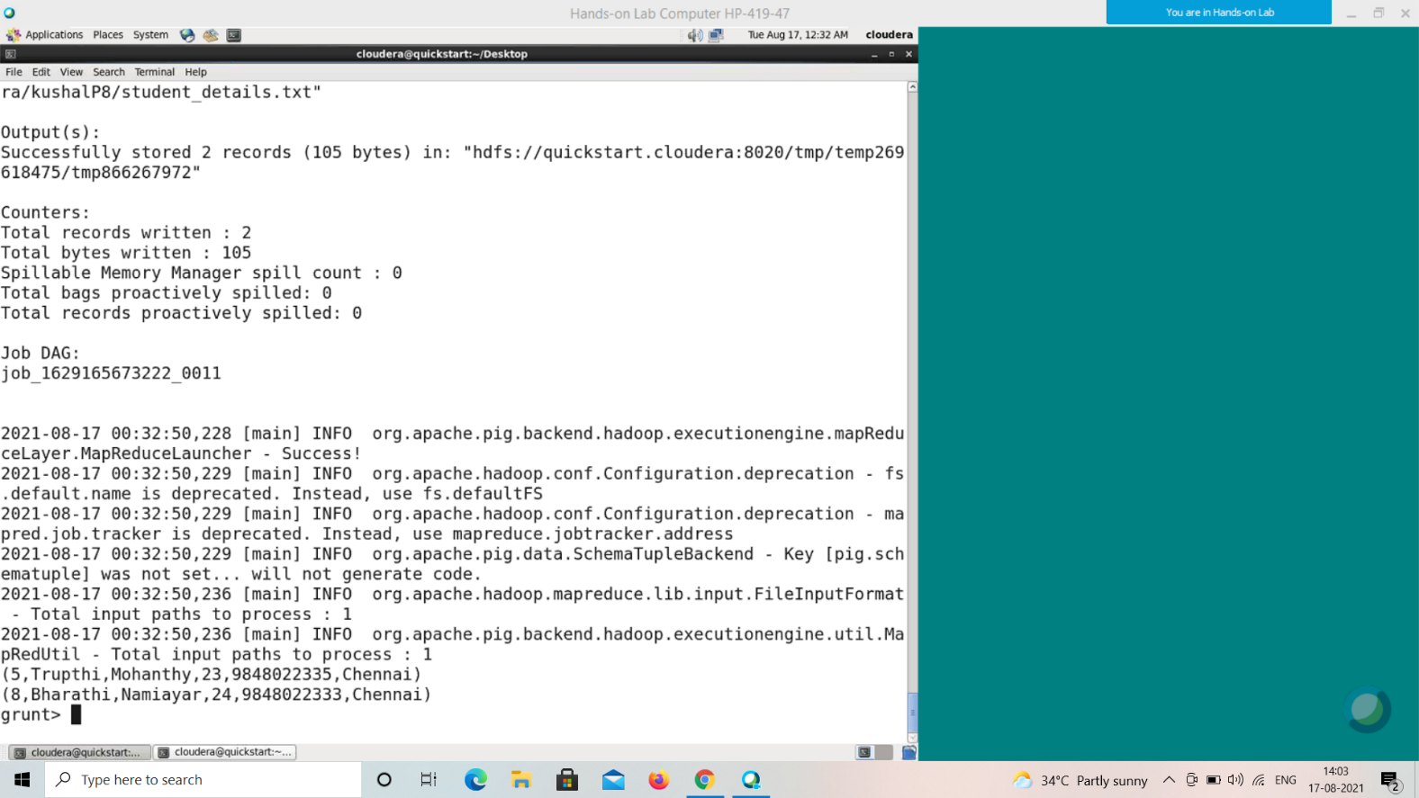

**Output**

It will produce the following output, displaying the contents of the relation **filter_data** as follows.

(6,Archana,Mishra,23,9848022335,Chennai)

(8,Bharathi,Nambiayar,24,9848022333,Chennai)

Distinct Operator

The **DISTINCT** operator is used to remove redundant (duplicate) tuples from a relation.

Syntax

Given below is the syntax of the **DISTINCT** operator.

grunt> Relation_name2 = DISTINCT Relatin_name1;

Example

Assume that we have a file named **student_details.txt** in the HDFS directory **/pig_data/** as shown below.

**student_details.txt**

001,Rajiv,Reddy,9848022337,Hyderabad

002,siddarth,Battacharya,9848022338,Kolkata

002,siddarth,Battacharya,9848022338,Kolkata

003,Rajesh,Khanna,9848022339,Delhi

003,Rajesh,Khanna,9848022339,Delhi

004,Preethi,Agarwal,9848022330,Pune

005,Trupthi,Mohanthy,9848022336,Bhuwaneshwar

006,Archana,Mishra,9848022335,Chennai

006,Archana,Mishra,9848022335,Chennai

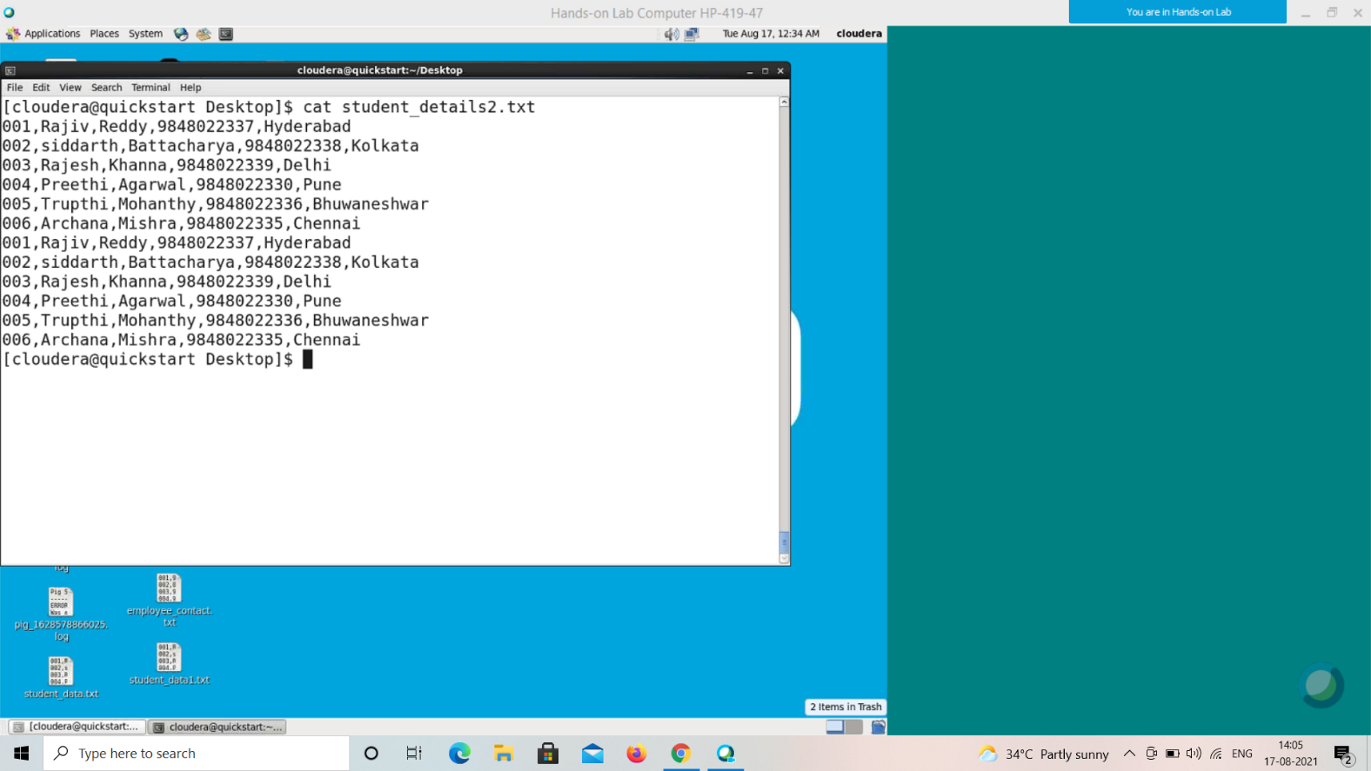

And we have loaded this file into Pig with the relation name **student_details** as shown below.

|  |
| --- |
| grunt> student_details = LOAD  'hdfs://localhost:9000/pig_data/student_details.txt' USING PigStorage(',')  as (id:int, firstname:chararray, lastname:chararray, phone:chararray, city:chararray); |

grunt> student_details2 = load ‘smitrpatel/student_details1.txt’ using PigStorage(‘,’) as (id:int, firstname:chararray, lastname:chararray, age:int, phone:chararray, city:chararray);

grunt> student_details = load 'smitrpatel/student_details2'

>> using PigStorage(',') as

>> (id:int, firstname:chararray, lastname:chararray, phone:chararray, city:chararray);

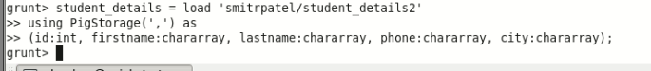

Let us now remove the redundant (duplicate) tuples from the relation named **student_details** using the **DISTINCT** operator, and store it as another relation named **distinct_data** as shown below.

grunt> distinct_data = DISTINCT student_details;

**Verification**

Verify the relation **distinct_data** using the **DUMP** operator as shown below.

|  |
| --- |
| grunt> Dump distinct_data; |

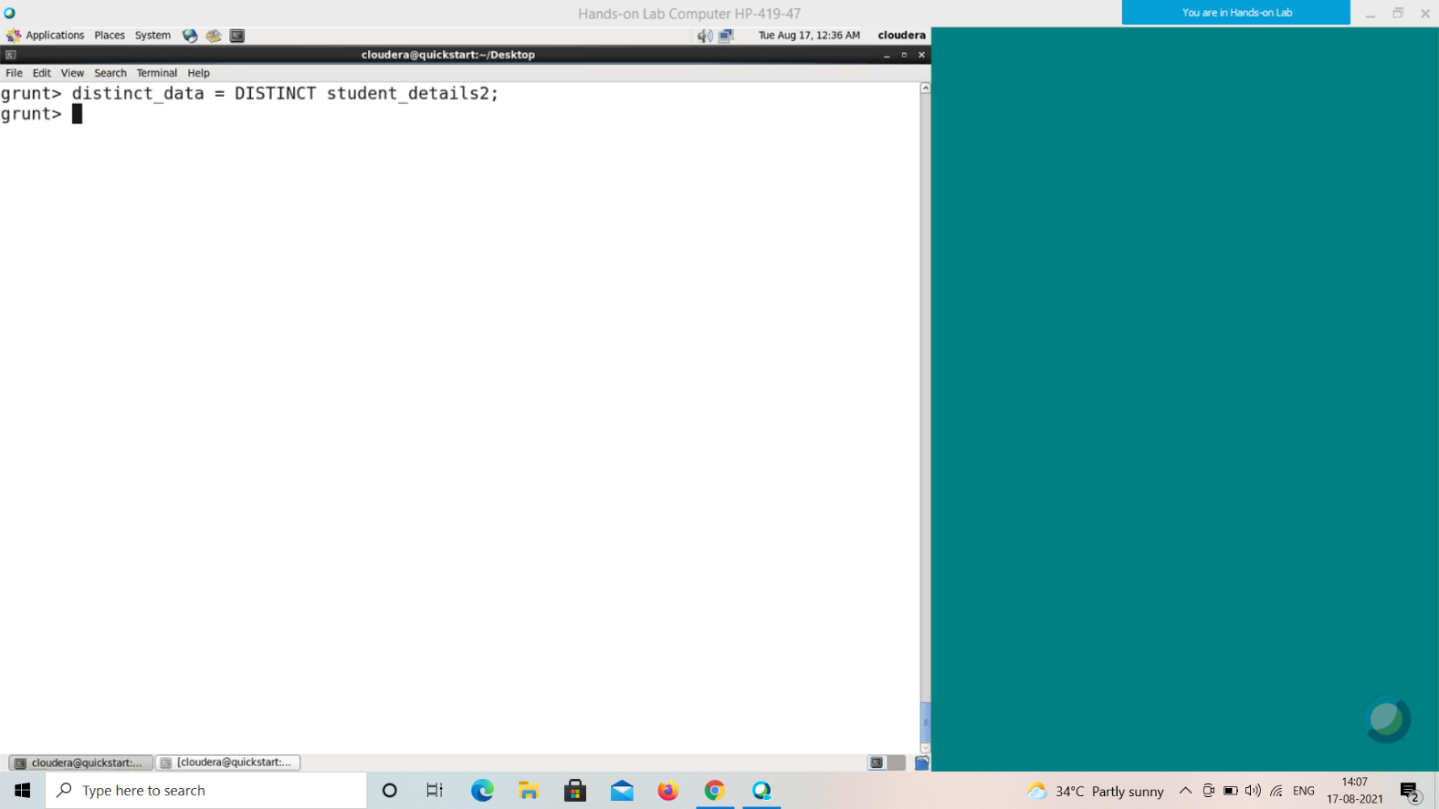

**Output**

It will produce the following output, displaying the contents of the relation **distinct_data** as follows.

(1,Rajiv,Reddy,9848022337,Hyderabad)

(2,siddarth,Battacharya,9848022338,Kolkata)

(3,Rajesh,Khanna,9848022339,Delhi)

(4,Preethi,Agarwal,9848022330,Pune)

(5,Trupthi,Mohanthy,9848022336,Bhuwaneshwar)

(6,Archana,Mishra,9848022335,Chennai)

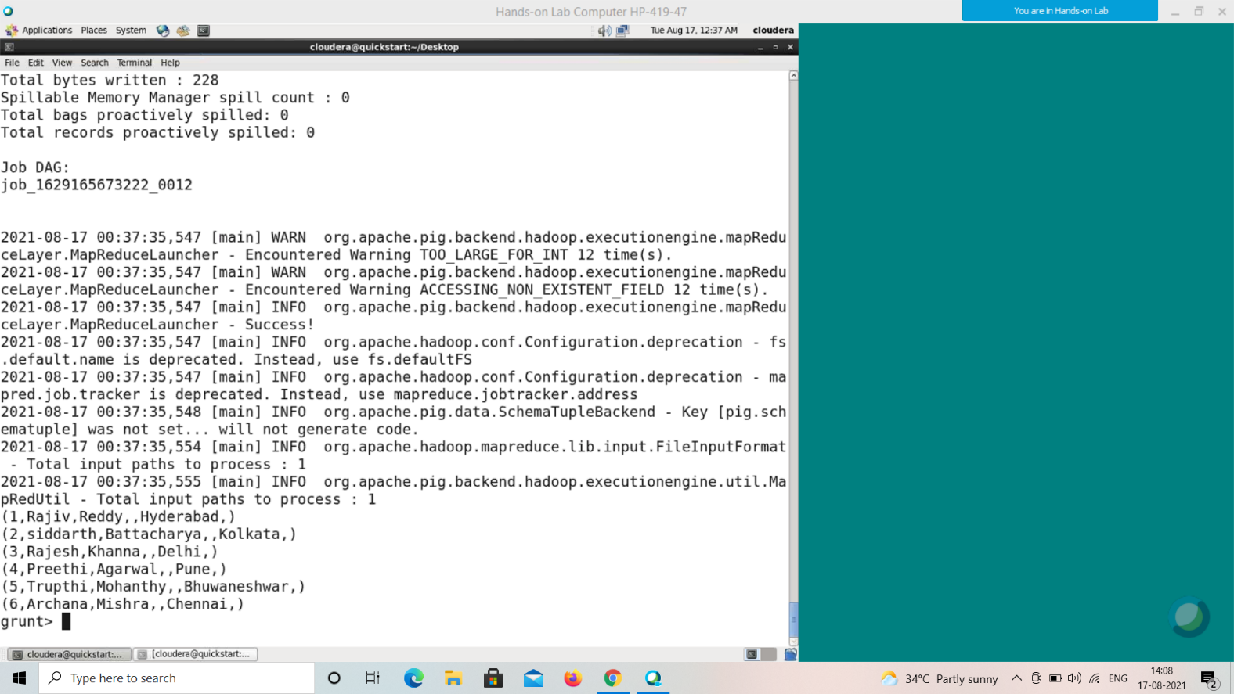

Foreach Operator

The **FOREACH** operator is used to generate specified data transformations based on the column data.

Syntax

Given below is the syntax of **FOREACH** operator.

grunt> Relation_name2 = FOREACH Relatin_name1 GENERATE (required data);

Example

Assume that we have a file named **student_details.txt** in the HDFS directory **/pig_data/** as shown below.

**student_details.txt**

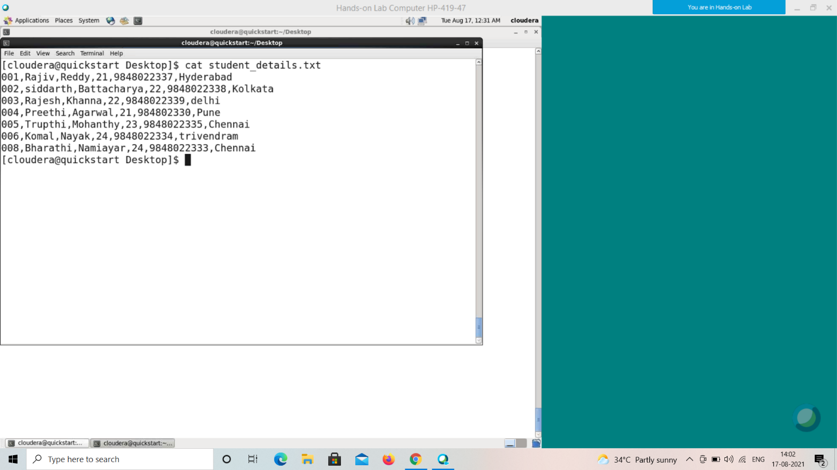

001,Rajiv,Reddy,21,9848022337,Hyderabad

002,siddarth,Battacharya,22,9848022338,Kolkata

003,Rajesh,Khanna,22,9848022339,Delhi

004,Preethi,Agarwal,21,9848022330,Pune

005,Trupthi,Mohanthy,23,9848022336,Bhuwaneshwar

006,Archana,Mishra,23,9848022335,Chennai

007,Komal,Nayak,24,9848022334,trivendram

008,Bharathi,Nambiayar,24,9848022333,Chennai

And we have loaded this file into Pig with the relation name **student_details** as shown below.

|  |
| --- |
| grunt> student_details = LOAD  'hdfs://localhost:9000/pig_data/student_details.txt' USING PigStorage(',')  as (id:int, firstname:chararray, lastname:chararray,age:int, phone:chararray, city:chararray); |

Let us now get the id, age, and city values of each student from the relation **student_details** and store it into another relation named **foreach_data** using the **foreach** operator as shown below.

|  |
| --- |
| grunt> foreach_data = FOREACH student_details GENERATE id,age,city; |

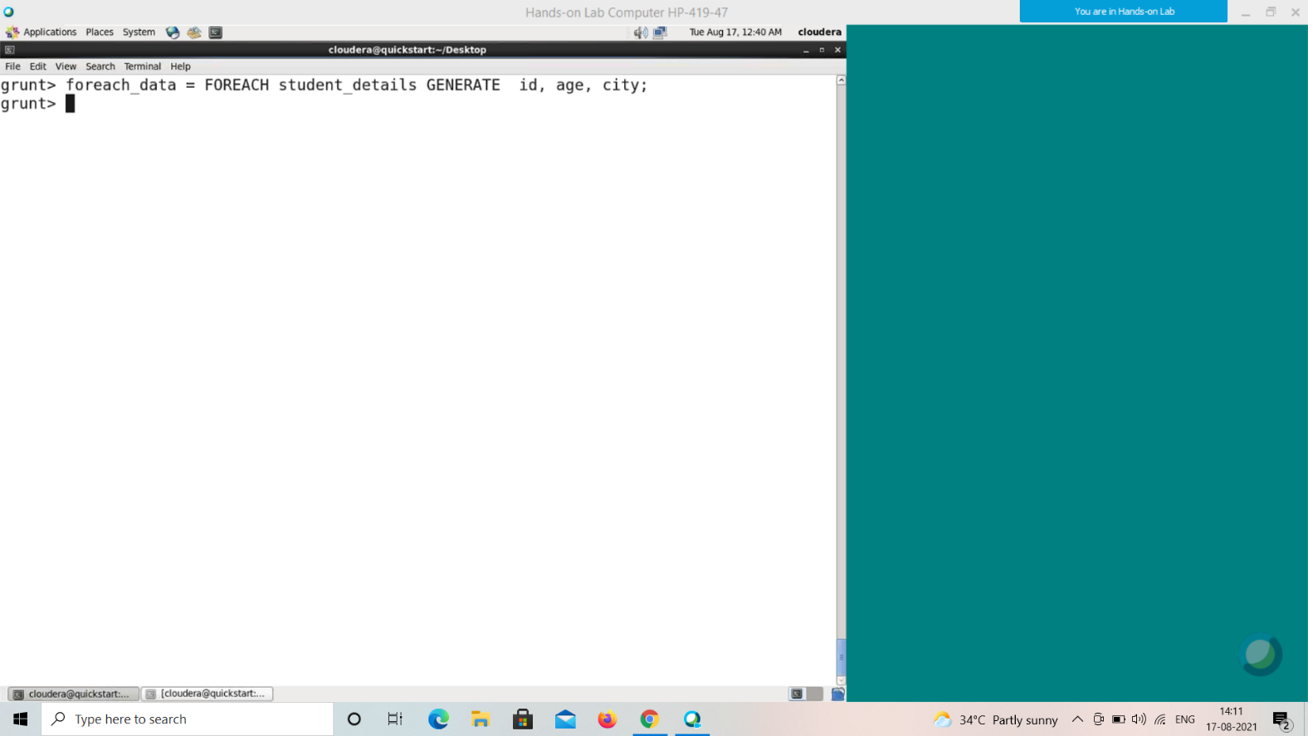

**Verification**

Verify the relation **foreach_data** using the **DUMP** operator as shown below.

|  |
| --- |
| grunt> Dump foreach_data; |

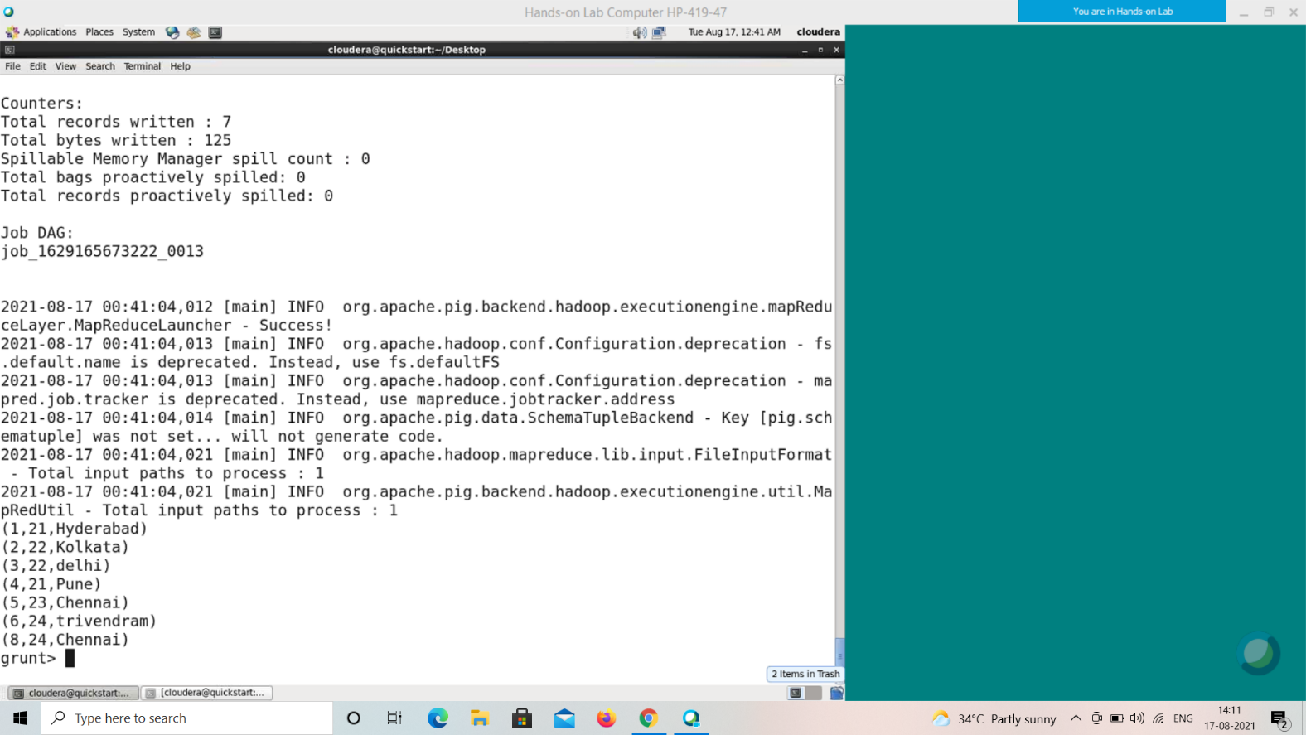

**Output**

It will produce the following output, displaying the contents of the relation **foreach_data**.

(1,21,Hyderabad)

(2,22,Kolkata)

(3,22,Delhi)

(4,21,Pune)

(5,23,Bhuwaneshwar)

(6,23,Chennai)

(7,24,trivendram)

(8,24,Chennai)

Order By

The **ORDER BY** operator is used to display the contents of a relation in a sorted order based on one or more fields.

Syntax

Given below is the syntax of the **ORDER BY** operator.

grunt> Relation_name2 = ORDER Relatin_name1 BY (ASC|DESC); Example

Assume that we have a file named **student_details.txt** in the HDFS directory **/pig_data/** as shown below.

**student_details.txt**



001,Rajiv,Reddy,21,9848022337,Hyderabad

002,siddarth,Battacharya,22,9848022338,Kolkata

003,Rajesh,Khanna,22,9848022339,Delhi

004,Preethi,Agarwal,21,9848022330,Pune

005,Trupthi,Mohanthy,23,9848022336,Bhuwaneshwar

006,Archana,Mishra,23,9848022335,Chennai

007,Komal,Nayak,24,9848022334,trivendram

008,Bharathi,Nambiayar,24,9848022333,Chennai

And we have loaded this file into Pig with the relation name **student_details** as shown below.

|  |
| --- |
| grunt> student_details = LOAD  'hdfs://localhost:9000/pig_data/student_details.txt' USING PigStorage(',')  as (id:int, firstname:chararray, lastname:chararray,age:int, phone:chararray, city:chararray); |

Let us now sort the relation in a descending order based on the age of the student and store it into another relation named **order_by_data** using the **ORDER BY** operator as shown below.

|  |
| --- |
| grunt> order_by_data = ORDER student_details BY age DESC; |

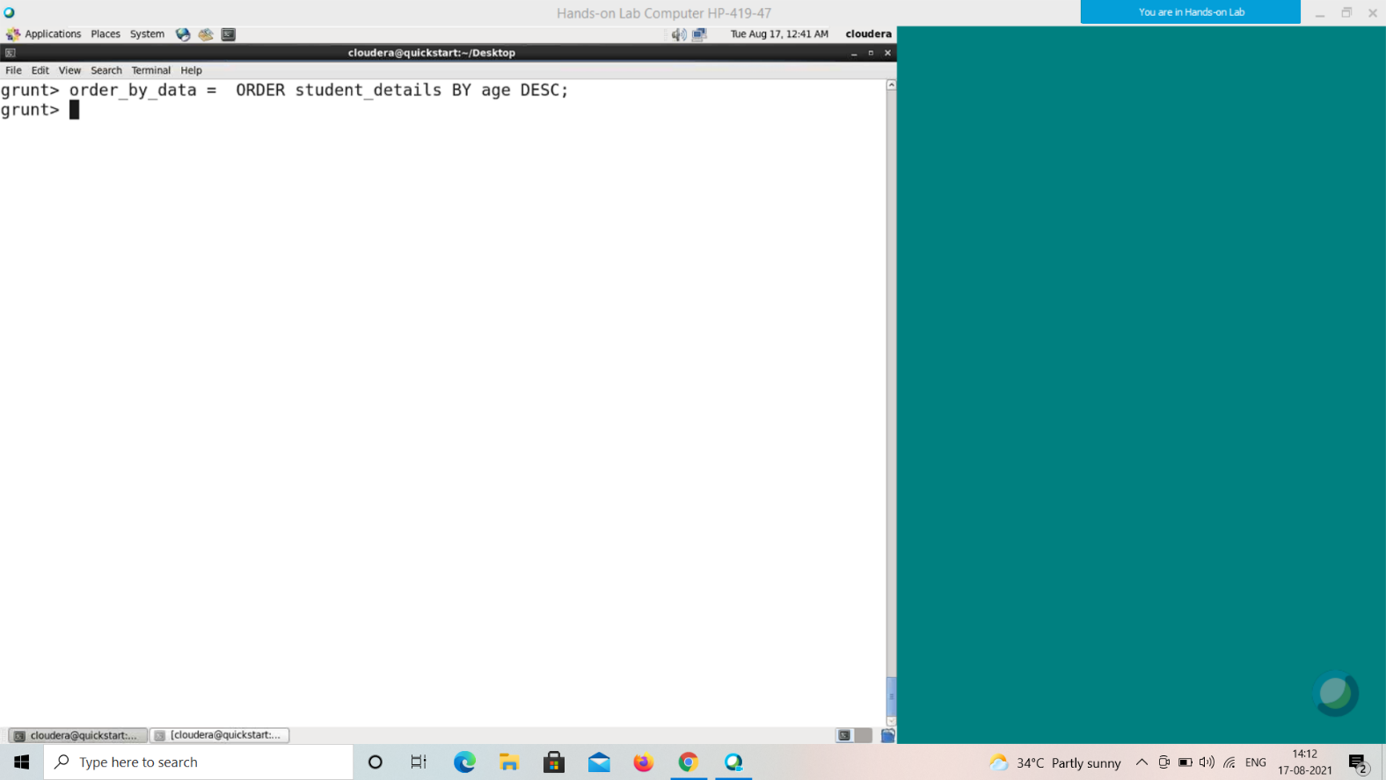

**Verification**

Verify the relation **order_by_data** using the **DUMP** operator as shown below.

|  |
| --- |
| grunt> Dump order_by_data; |

**Output**

It will produce the following output, displaying the contents of the relation **order_by_data**.

(8,Bharathi,Nambiayar,24,9848022333,Chennai)

(7,Komal,Nayak,24,9848022334,trivendram)

(6,Archana,Mishra,23,9848022335,Chennai)

(5,Trupthi,Mohanthy,23,9848022336,Bhuwaneshwar)

(3,Rajesh,Khanna,22,9848022339,Delhi)

(2,siddarth,Battacharya,22,9848022338,Kolkata)

(4,Preethi,Agarwal,21,9848022330,Pune)

(1,Rajiv,Reddy,21,9848022337,Hyderabad)

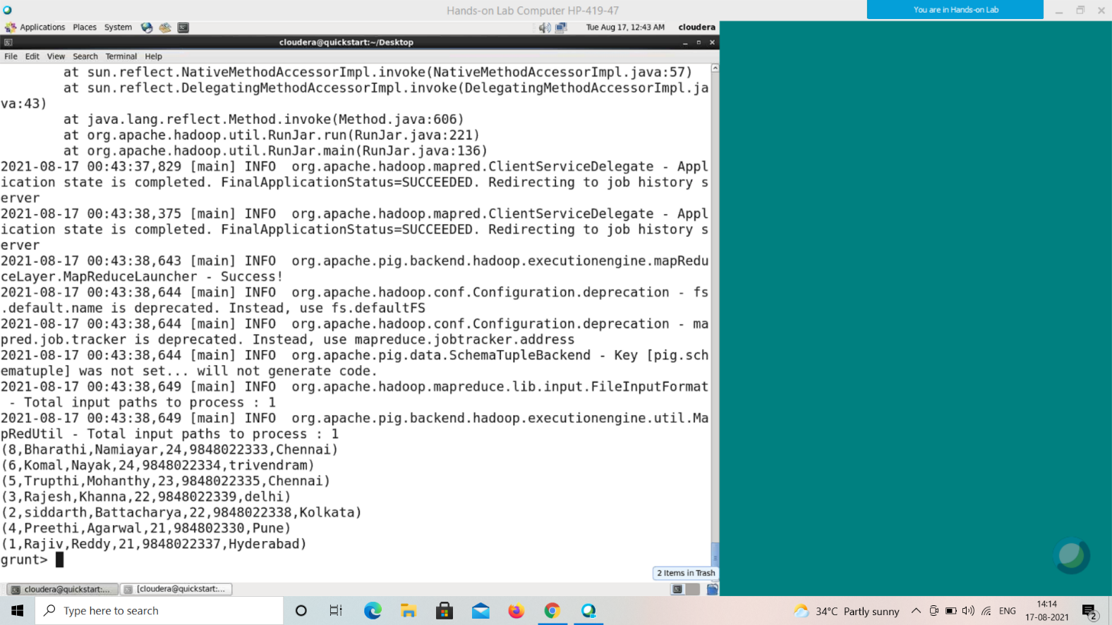

Limit Operator

The **LIMIT** operator is used to get a limited number of tuples from a relation. Syntax

Given below is the syntax of the **LIMIT** operator.

grunt> Result = LIMIT Relation_name required number of tuples; Example

Assume that we have a file named **student_details.txt** in the HDFS directory **/pig_data/** as shown below.

**student_details.txt**



001,Rajiv,Reddy,21,9848022337,Hyderabad

002,siddarth,Battacharya,22,9848022338,Kolkata

003,Rajesh,Khanna,22,9848022339,Delhi

004,Preethi,Agarwal,21,9848022330,Pune

005,Trupthi,Mohanthy,23,9848022336,Bhuwaneshwar

006,Archana,Mishra,23,9848022335,Chennai

007,Komal,Nayak,24,9848022334,trivendram

008,Bharathi,Nambiayar,24,9848022333,Chennai

And we have loaded this file into Pig with the relation name **student_details** as shown below.

|  |
| --- |
| grunt> student_details = LOAD  'hdfs://localhost:9000/pig_data/student_details.txt' USING PigStorage(',')  as (id:int, firstname:chararray, lastname:chararray,age:int, phone:chararray, city:chararray); |

Now, let’s sort the relation in descending order based on the age of the student and store it into another relation named **limit_data** using the **ORDER BY** operator as shown below.

|  |
| --- |
| grunt> limit_data = LIMIT student_details 4; |

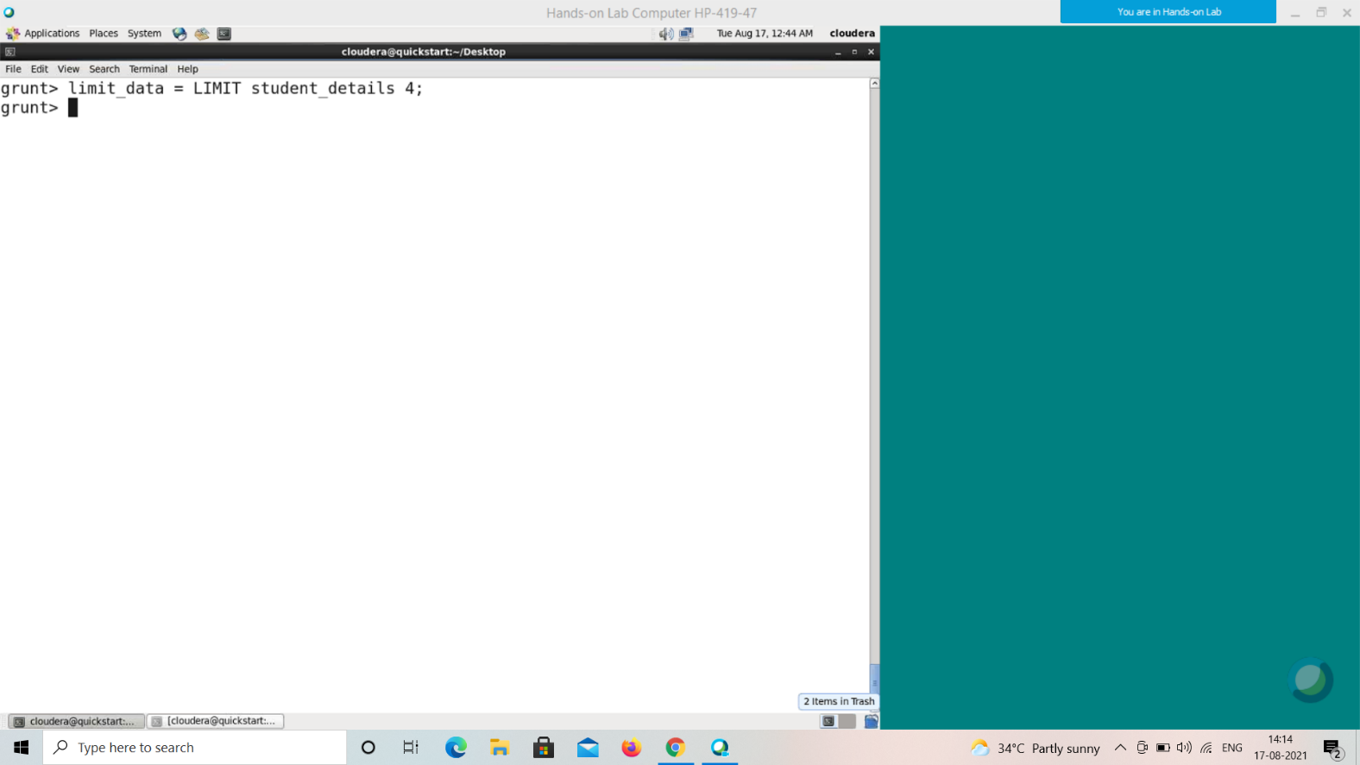

**Verification**

Verify the relation **limit_data** using the **DUMP** operator as shown below.

|  |
| --- |
| grunt> Dump limit_data; |

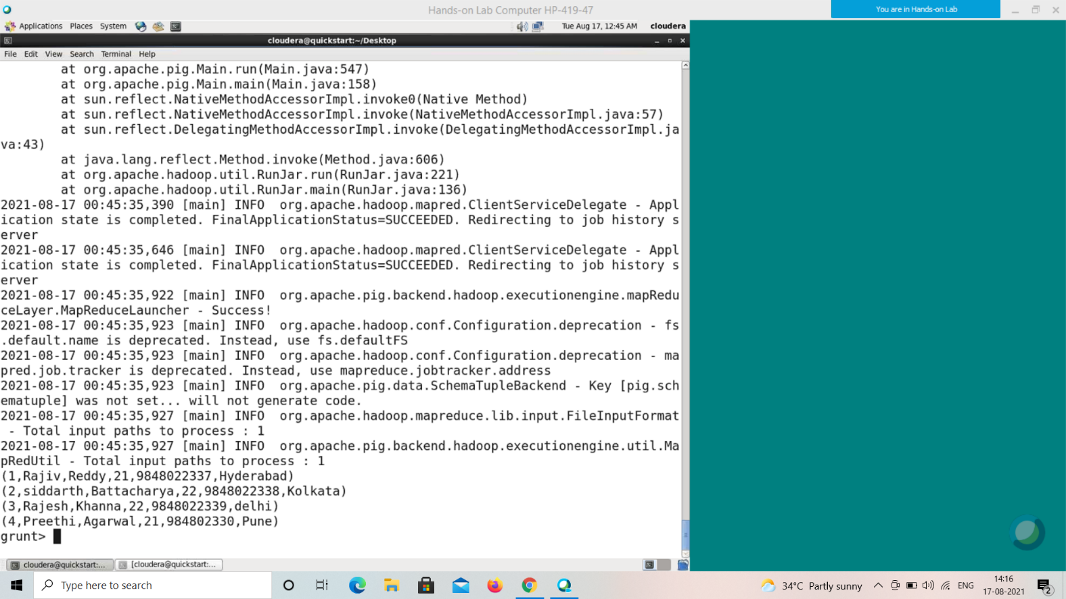

**Output**

It will produce the following output, displaying the contents of the relation **limit_data** as follows.

(1,Rajiv,Reddy,21,9848022337,Hyderabad)

(2,siddarth,Battacharya,22,9848022338,Kolkata)

(3,Rajesh,Khanna,22,9848022339,Delhi) (4,Preethi,Agarwal,21,9848022330,Pune)